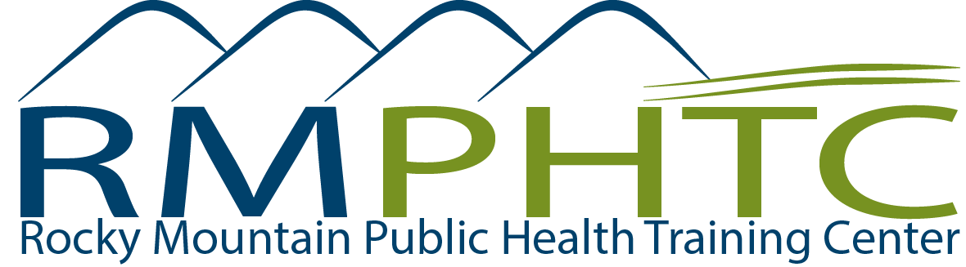

Public Health Student Stipend – Announcement
2014/2015 Academic Year

Stipend Amount: $1,500/student/year

Number of Stipends Awarded: 20 across HHS Region VIII (Colorado, Utah, Wyoming, Montana, North Dakota, and South Dakota). Four stipends will be available for students in each state.

Purpose: This stipend will help support field placements and collaborative learning projects of students enrolled in a masters or doctoral level public health program.

Eligibility
- Students must be currently enrolled in a MPH/DrPH/or PhD program in a School or Program of Public Health in HHS Region VIII (Colorado, Utah, Wyoming, Montana, North Dakota, South Dakota).
- Preference will be given to students doing their field placement or project in a rural or frontier area, working with underserved populations, and/or students working to support tribal health on a reservation or Urban Indian Health.
- Student field placements must take place in the Region VIII states (Colorado, Utah, Wyoming, Montana, North Dakota, or South Dakota).

Selection Criteria:

- Extent to which the project serves a rural or frontier area, underserved populations, and/or students working to support tribal health on a reservation or Urban Indian Health.
- Extent to which the project achieves the educational goals of the UM Public Health Master’s Program
- Evidence of professional and scholarly involvement by student
- Feasibility and likelihood that the field placement or project will be completed in a timely manner
- Evidence of contact with organizations essential to completion of the project
Each regional Collaborative Site will submit a list of selected students and their contact information to Amanda Skenadore (Amanda.skenadore@ucdenver.edu) at the RM-PHTC by December 12, 2014.

Final Step:
Selected students will need to complete a brief online RM-PHTC Student Stipend Form between December 15 – 31, 2014.

Sponsored By: The Rocky Mountain Public Health Training Center
The Rocky Mountain Public Health Training Center (RM-PHTC) is one of 10 regional Public Health Training Centers funded by Health Resources and Services Administration (HRSA). The purpose of the Regional PHTC Program is to improve the nation’s health system by strengthening the technical, scientific, and managerial and leadership competencies of the current and public health workforce. The RM-PHTC serves the six states of HHS Region VIII: Colorado, Wyoming, Utah, Montana, North Dakota, and South Dakota.

https://www.publichealthpractice.org/training-category/Rocky-Mountain-Public-Health-Training-Center

The four legislative requirements of the PHTCs are to:
- Establish or strengthen field placements for students.
- Facilitate faculty and student collaborative projects
- Designate a geographic area to be served.
- Assess health personnel needs of the area to be served and develop trainings to meet such needs.

