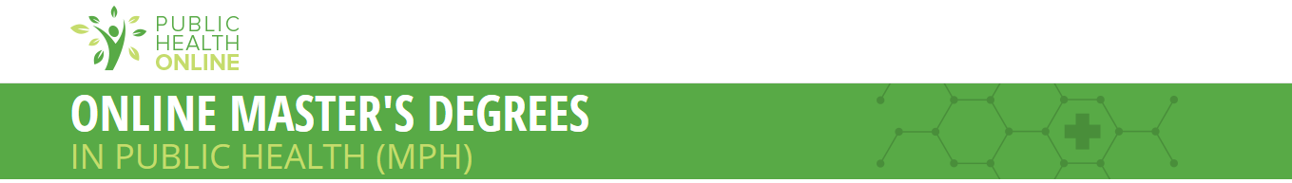

PublicHealthOnline.org, a leading online resource for public health education and careers, recently published a new list of the Best Online MPH Programs for 2014-15.

Our organization recently analyzed data from hundreds of available online public health degree programs to find out which colleges truly excel at online learning at the master’s level. I'm excited to share that The University of Montana has been recognized for having one of the Best Online MPH Programs of 2014-15.
Our data analysts and higher education experts developed a proprietary scoring system to rank these master’s programs using various cost, quality and student support metrics, as shown below.
Scoring metrics and rankings criteria:

- Online tuition cost
- Academic/career counseling service
- Placement services for graduates
- CEPH accreditation
- Public, not-for-profit institutions only
- Must offer 4-year programs
- Must offer an online MPH
Online MPH programs help advanced students in the public health field earn an advanced degree in a flexible learning environment. Many offer a wide range of resources, specialization opportunities and even job placement to facilitate the transition from college to career. The schools have online MPH programs that truly stand out, from affordable tuition and fees to faculty and support services that truly make a difference.
Included programs not only meet the standard of excellence of traditional on-campus public health programs, but also provide students the flexibility to continue their higher education through the graduate level while working and building experience in their chosen field.
"Many public health careers require a master’s degree," said Wes Harris, founder of Public Health Online. "Today’s working professionals need the flexible learning options these online MPH programs offer."
There has been a 23 percent increase in the number of accredited public health programs, and, according to the Bureau of Labor and Statistics, health education, community health and other public health-related occupations are expected to grow faster than average.
"Earning a master’s degree and having work experience could be the difference between getting the job and not,” said Harris. "It’s important for students and working professionals to know their options when it comes to furthering their careers."
On Thursday, we plan to share the ranking with local and national news outlets. In the meantime, please feel free to promote your ranking when and where you see fit.

Congratulations again on your recognition for excellence in online education in public health at the master’s level.

Sincerely,
Teresa Mullins
Director, Community Outreach & Partnerships

You can view the ranking and data at the following location:
http://www.publichealthonline.org/degree-programs/masters/
